NAME: G. Yashmita REG NO: 192511032
EXPERIMENT 5:
Using Raptor – Draw and validate a flowchart for a given string of lower
case English alphabets. One can choose any two characters in the string
and replace all the occurrences of the first character with the second
character and replace all the occurrences of the second character with
the first character. Using Raptor draw and validate the flowchart
lexicographically smallest string that can be obtained by doing this
operation at most once.

Aim
The objective of this experiment is to draw and validate a flowchart in RAPTOR that accepts a string of lowercase English alphabets and generates the lexicographically smallest string by swapping all occurrences of two selected characters at most once.

Software Requirements
Software: RAPTOR Flowchart Software
Operating System: Windows 10/11
Hardware: PC/Laptop
Input Device: Keyboard

Theory
RAPTOR is a flowchart-based programming environment used to design and test algorithms visually. In this experiment, a string containing only lowercase English letters is provided as input. The algorithm identifies two characters whose complete interchange results in the lexicographically smallest possible string. The operation can be performed only once, where every occurrence of the first selected character is replaced with the second character and vice versa. This experiment demonstrates string manipulation, character replacement, and optimization techniques using flowchart programming.

Procedure

Step 1:
Open the RAPTOR application and create a new flowchart.

Step 2:
Insert an Input symbol to accept a string containing lowercase English alphabets.

Step 3:
Use assignment and decision symbols to compare the characters in the string and identify the pair of characters whose interchange produces the smallest lexicographical order.

Step 4:
Replace every occurrence of the first selected character with the second character and replace every occurrence of the second character with the first character. Ensure that this replacement is performed only once.

Step 5:
Store the modified string and display it using an Output symbol.

Step 6:
Execute the flowchart with different input strings and verify that the generated string is the lexicographically smallest possible after performing at most one swap.
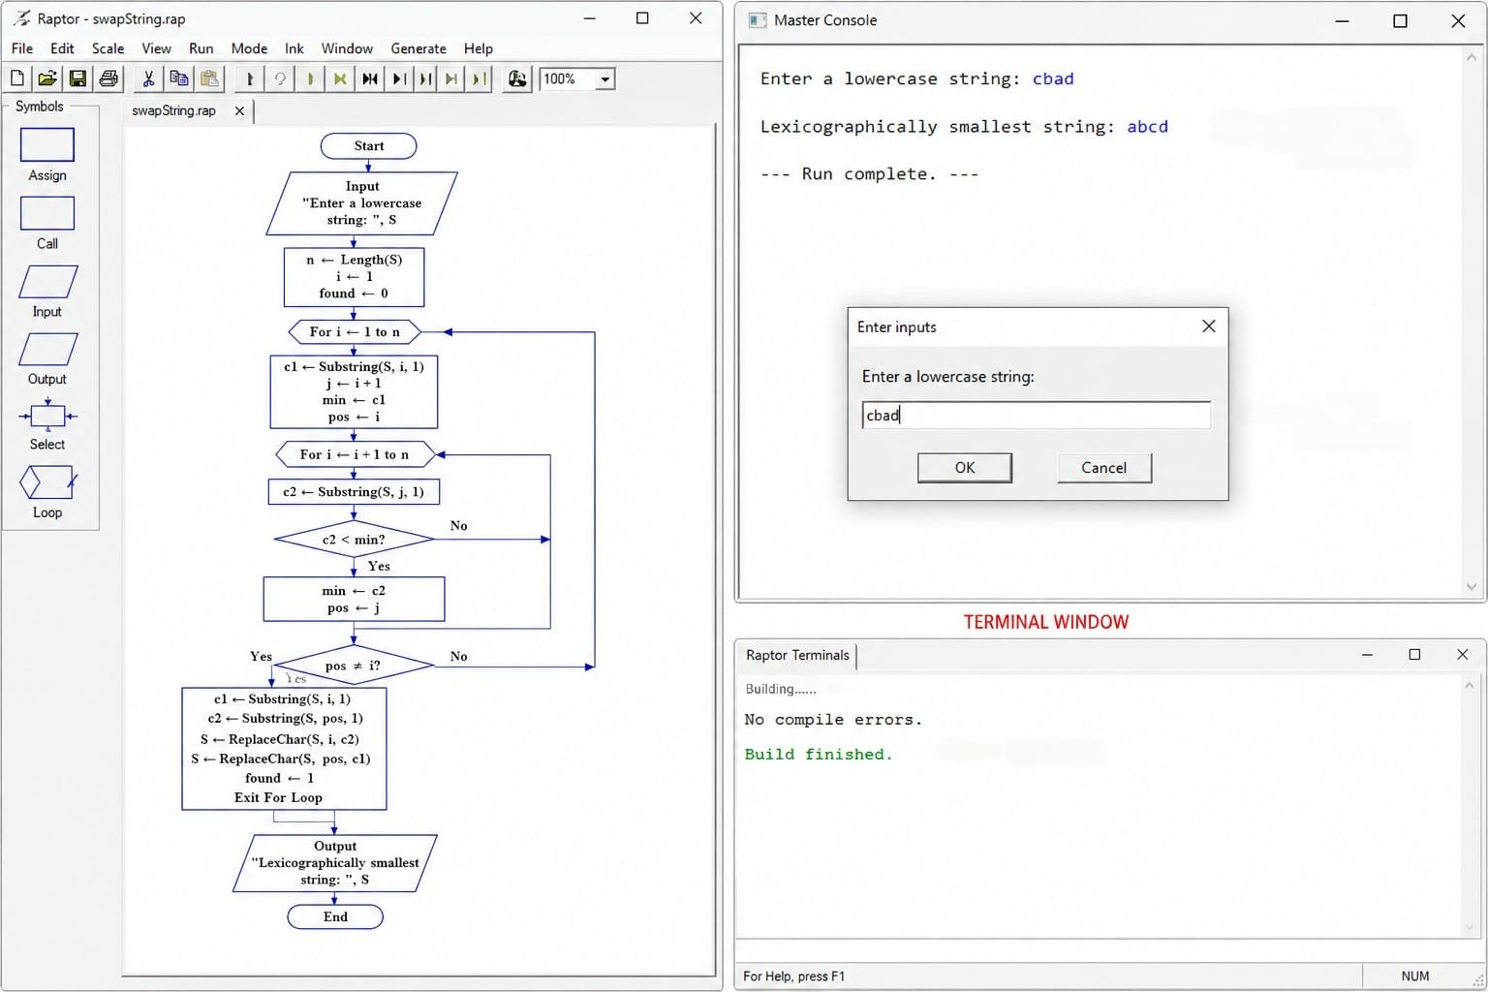
Figure 1. Execution of the Flowchart.

Result
The flowchart was successfully designed and validated using RAPTOR to generate the lexicographically smallest string by swapping all occurrences of two selected characters at most once. The experiment demonstrated the use of decision-making, string processing, character replacement, and optimization techniques through flowchart-based programming.

